Bangladesh University Of Business & Technology



LAB REPORT

Course Code : CSE-207

Course Title : Database Systems

Experiment Name : Create database & table, Insert data in table and searching from the database table using SQL commands using Xammp software.

Experiment No. : 01

Intake : 45

Section : 02

Program : B.sc. Engg in CSE

SUBMITTED BY : Shamsi Juma(068)

SUBMITTED TO : Zobaer Zihad Lecturer, Department of CSE, BUBT.

Create customer table:

CREATE TABLE customer_table ( customer_name varchar(250), customer_street varchar(250), customer_city varchar(250), PRIMARY KEY (customer_name ) );

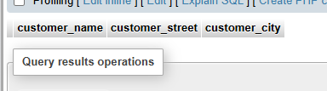

Insert value for customer_table:

INSERT INTO customer_table VALUES

('Adams', 'Spring', 'Pittsfield'),

('Brooks', 'Senator', 'Brooklyn'),

('Curry', 'North', 'Rye'),

('Glenn', 'Sand Hill', 'Woodside'),

('Green', 'Walnut', 'Stamford'),

('Hayes', 'Main', 'Harrison'),

('Johnson', 'Alma', 'Palo Alto'),

('Jones', 'Main', 'Harrison'),

('Lindsay', 'Park', 'Pittsfield'),

('Smith', 'North', 'Rye'),

('Turner', 'Putnam', 'Stamford'),

('Williams', 'Nassau', 'Princeton');

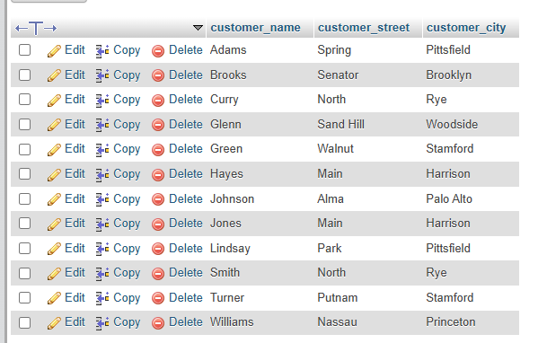

Create loan_table:

CREATE TABLE loan_table ( loan_number varchar(250), branch_name varchar(250), amount INT );

And Insert value:

INSERT INTO loan_table VALUES

('L-11', 'Round Hill', 900),

('L-14', 'Downtown', 1500),

('L-15', 'Perryridge', 1500),

('L-16', 'Perryridge', 1300),

('L-17', 'Downtown', 1000),

('L-23', 'Redwood', 2000),

('L-93', 'Manus', 500);

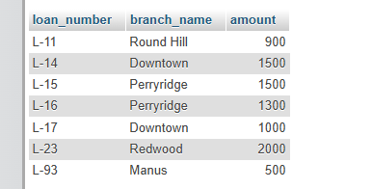

CREATE TABLE borrow_table ( customer_name varchar(250), loan_number varchar(250), PRIMARY KEY (customer_name, loan_number),FOREIGN KEY (customer_name) REFERENCES customer_table(customer_name), FOREIGN KEY (loan_number) REFERENCES loan_table(loan_number) );

INSERT INTO borrow_table VALUES

('Adams', 'L-16'),

('Curry', 'L-93'),

('Hayes', 'L-15'),

('Johnson', 'L-14'),

('Jones', 'L-17'),

('Smith', 'L-11'),

('Smith', 'L-23'),

('Williams', 'L-17');

Q.1 find the names of all branches in the loan table:

SELECT DISTINCT branch_name FROM loan_table;

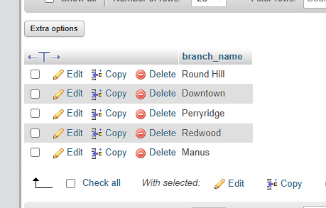

Q2. Find all loan numbers for loans made at the "Perryidge" branch with load amount greater then 300.

SELECT loan_number FROM loan_table WHERE branch_name = 'Downtown' AND amount > 300;

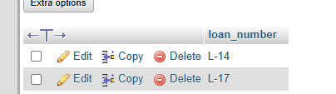

Q3. Find all the load number and customer name who has loan either "Perryride" branch or "Downtown" branch.

Q4.

Find all the loan numbers of the customers who has loan either "Perryridge" branch or "Downtown" branch "Mianus" branch.

SELECT loan_number FROM loan_table WHERE branch_name IN ('Perryridge', 'Downtown', 'Mianus')

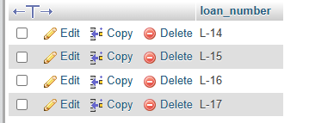

Q5. Find the names of all customers who are not from "Stamford" or "Princeon" or "Harrison" city.

SELECT customer_name FROM customer_table WHERE customer_city NOT IN ('Stam

ford', 'Princeton', 'Harrison');

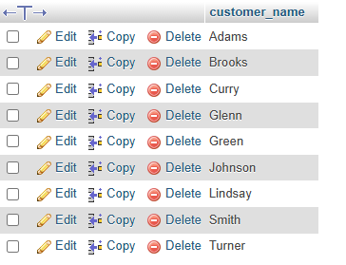

Q6. Find the loan number of those loans with loan amount between 400 and 800

SELECT loan_number FROM loan_table WHERE amount BETWEEN 400 AND 800;

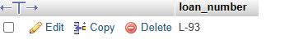

Q7. Find the names of all customers whose name start with "G".

SELECT customer_name FROM customer_table WHERE customer_name LIKE 'G%';

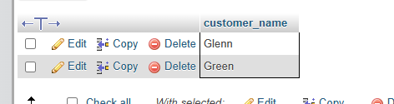

Q8. Find the street and city of the customer whose loan amount is greater than 1200